# CS 499 Module One Assignment by Leah Marshall

1. **Self-Introduction:** Address all of the following questions to introduce yourself.
   1. How long have you been in the Computer Science program?

**Even though this is my last year of my Bachelor’s degree, I’ve only been in the Computer Science program for two years. My original major was Mathematics, but I thought Computer Science would fit my needs and goals a lot better.**

* 1. What have you learned while in the program? List three of the most important concepts or skills you have learned.

**I’ve learned a lot while within this program. For starters, I’ve gotten a greater grasp on my coding skills and have learned how to create a consistent and thorough portfolio. Moreover, since each class I’ve taken requires best practices of coding, I like to think I’ve become a pro at creating clear, easy to read code.**

* 1. Discuss the specific skills you aim to demonstrate through your enhancements to reach each of the course outcomes.

**Some specific skills that I aim to demonstrate will be my consistency, cleanliness, and professionalism. By creating excellent submissions for this course, I hope to showcase these aspects within my work.**

* 1. How do the specific skills you will demonstrate align with your career plans related to your degree?

**Since I plan to work in the computing field, where employers expect to be able to easily view and understand my work, I hope to already have this skill set mastered.**

* 1. How does this contribute to the specialization you are targeting for your career?

**I hope to work within the data world as either an analyst or hopefully a data architect where code needs to be precise and secure. By keeping best practices within my work, I should have no problem living up to my employer’s expectations.**

1. **ePortfolio Set Up:**
   1. Submit a **screen capture** of your ePortfolio home page that clearly shows your URL.
      1. You already have a repository in GitHub where you uploaded projects in previous courses. Your ePortfolio will reside in GitHub but can link to work at other sites, such as Bitbucket.
   2. Use the GitHub Pages link in the Resource section for directions on:
      1. How to create your GitHub website and publish code to GitHub Pages
      2. Issues, such as adding links to other sites
   3. Paste a screenshot of your GitHub Homepage with your URL clearly showing in the space below.

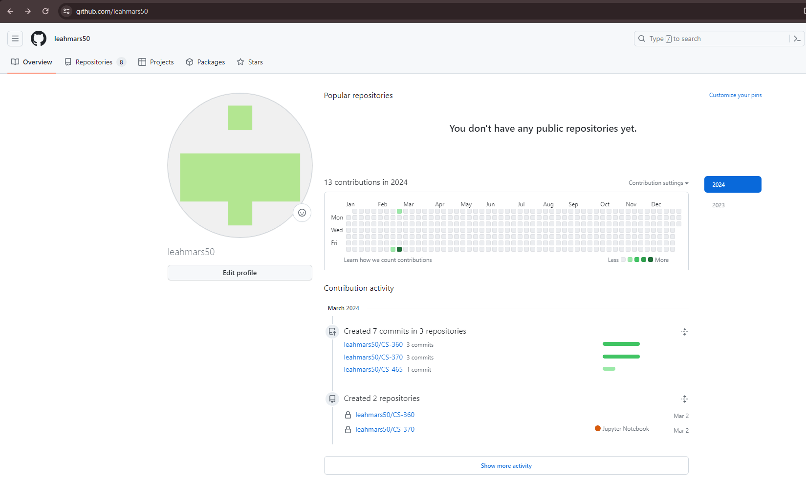

1. **Enhancement Plan:** 
   1. **Category One:** Software Engineering and Design
      1. **Select an** **artifact** that is **aligned with** **the** software engineering and design **category** and explain its origin. Submit a file containing the code for the artifact you choose with your enhancement plan.

**I chose an artifact from my previous class, IT-145. For the first project within this course, we were tasked to create a simple file which contained a constructor, setter methods, and getter methods for an application meant to check pets into a boarding & grooming business.**

* + 1. **Describe** a practical, well-illustrated **plan** for enhancement in alignment with the category, including a pseudocode or flowchart that illustrates the planned enhancement.

**I plan to create an android application for this category. This will include asking the user for all the same information that the original pet.java does, but in a more user-friendly environment. I will begin by creating all necessary aesthetics for the application including the background, color pallets, etc.. Then, I will create a home page with the option to add a pet to the registration list. This will include getting the pet’s species, name, how many days they’re staying, and if the pet is a dog, ask if they want grooming done to the pet. This will then add this information into a database for the administrator to access.**

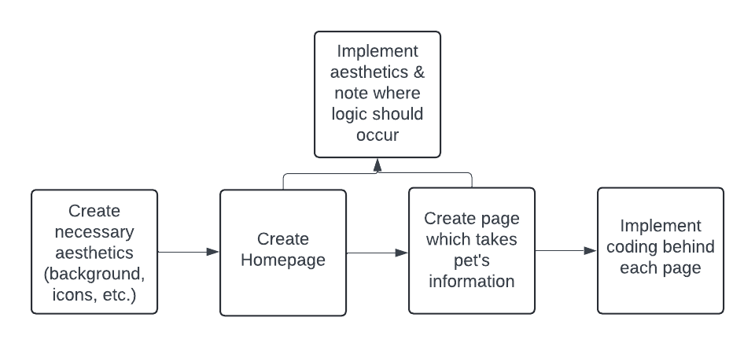

* + 1. Explain how the planned enhancement will **demonstrate** specific **skills** and align with course outcomes.
       1. Identify and describe the specific skills you will demonstrate that align with the course outcome.

**I will be actively creating and designing a professional-level app. Moreover, this will also enhance my own techniques within app development by looking for new ways to create a visually-appealing application. Moreover, I plan to use this application within my database milestone to create a login and sign-in screen.**

* + - 1. Select one or more of the course outcomes below that your enhancement will align with.

**Like I said in my previous answer, my enhancement will align with the following course outcomes:**

* **Design, develop, and deliver professional-quality oral, written, and visual communications that are coherent, technically sound, and appropriately adapted to specific audiences and contexts.**
* **Demonstrate an ability to use well-founded and innovative techniques, skills, and tools in computing practices for the purpose of implementing computer solutions that deliver value and accomplish industry-specific goals.**
  1. **Category Two:** Algorithms and Data Structures

1. **Select an artifact** that is **aligned with the** algorithms and data structures **category** and explain its origin. Submit a file containing the code for the artifact you choose with your enhancement plan. You may choose work from the courses listed under Category One.

**For this Category, I’m choosing my work from CS-410. Within my project, I brought up with how the previous code was not that secure as it did not have efficient login procedures and little to no data keeping for it. I would go back through and create this for the project,**

1. **Describe** a practical, well-illustrated **plan** for enhancement in alignment with the category, including a pseudocode or flowchart that illustrates the planned enhancement.

**To achieve this enhancement, I will first switch this program over to Java from C++. I am more comfortable with Java and would like to show off my skills within the program. I would then create an algorithm meant to encrypt the password and username needed for the system. Then, I would use this hashed password to verify credentials and thus letting users into the system. The system would stay simple, just like the original piece of work, except now it would allow users to Display and Add to the client list (before, you couldn’t add to the list). To add new clients, I will use an array list to keep track of the information. The system will ask for the first and last name plus their service choice with the bank. This can always be expanded, I just decided to keep it simple to showcase the hashing algorithm and the enhanced client list structure.**

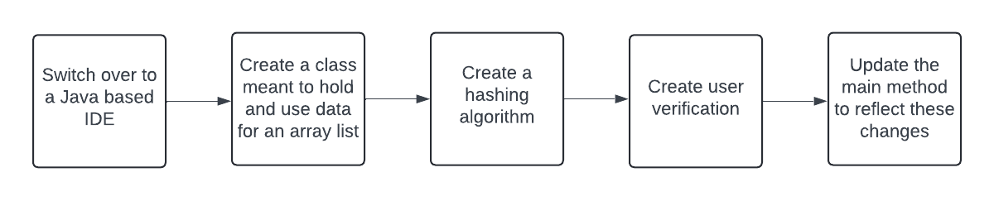

1. Explain how the planned enhancement will **demonstrate** specific **skills** and align with course outcomes.
   1. Identify and describe the specific skills you will demonstrate to align with the course outcome.

**Through revisiting this project, I will be actively keeping a security mindset by trying to keep data with the login process secure. The original artifact had no verification on passwords, usernames, choices when going through options, etc.. Moreover, by using inline comments and specifying what enhancements I’ve included this should allow future collaborators to easily see what I’ve written and what the purpose of each block of code is used for.**

* 1. Select one or more of the course outcomes listed under Category One that your enhancement will align with.

**This enhancement would align with the following course outcome:**

* **Develop a security mindset that anticipates adversarial exploits in software architecture and designs to expose potential vulnerabilities, mitigate design flaws, and ensure privacy and enhanced security of data and resources.**
* **Employ strategies for building collaborative environments that enable diverse audiences to support organizational decision-making in the field of computer science.**
* **Design, develop, and deliver professional-quality oral, written, and visual communications that are coherent, technically sound, and appropriately adapted to specific audiences and contexts.**
  1. **Category Three: Databases**
     1. **Select an artifact** that is **aligned with the** databases **category** and explain its origin. Submit a file containing the code for the artifact you choose with your enhancement plan. You may choose work from the courses listed under Category One.

**For this category, I’m continuing to add to the Software Engineering and Design artifact by adding databases to hold user’s specific information. The original pet.java did not have any outputs for user input, so by satisfying this need within the first artifact, I can then build onto that and keep records of whom replied what.**

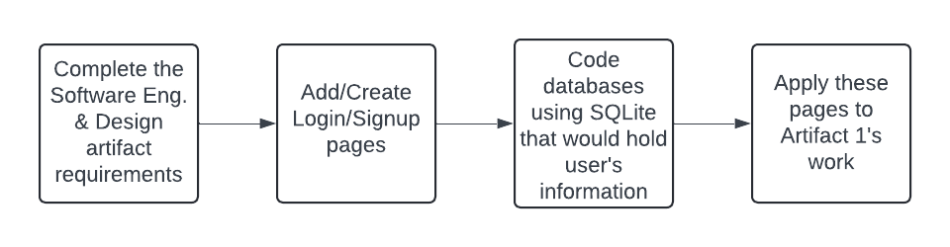

* + 1. **Describe** a practical, well-illustrated **plan** for enhancement in alignment with the category, including a pseudocode or flowchart that illustrates the planned enhancement.

**First, I will start off by creating a login/signup screen for the application. This will then create specific instances of the application, keeping better record of the registrations. Then, I will include industry standard practices for keeping this information within secure databases using SQLite.**

* + 1. Explain how the planned enhancement will **demonstrate** specific **skills** and align with course outcomes.
       1. Identify and describe the specific skills you will demonstrate that align with the course outcome.

**I will demonstrate my android studio knowledge with this application. These enhancements will not only show that I can create a visually appealing app, but I can make it functional as well, all while keeping the user in mind. Moreover, this will show that not only can I work with the Java used in Android Studio, but I can also combine this with SQL principles.**

* + - 1. Select one or more of the course outcomes listed under Category One that your enhancement will align with.

**The main course outcomes this would align with is:**

* **Design and evaluate computing solutions that solve a given problem using algorithmic principles and computer science practices and standards appropriate to its solution while managing the trade-offs involved in design choices.**
* **Demonstrate an ability to use well-founded and innovative techniques, skills, and tools in computing practices for the purpose of implementing computer solutions that deliver value and accomplish industry-specific goals.**
* **Develop a security mindset that anticipates adversarial exploits in software architecture and designs to expose potential vulnerabilities, mitigate design flaws, and ensure privacy and enhanced security of data and resources.**

1. **ePortfolio Overall Skill Set**
   1. Accurately describe the **skill set** to be illustrated by the **ePortfolio** **overall**.
      1. Skills and outcomes planned to be illustrated in the code review

**Through my code review, I will be revisiting multiple projects with the hopes of fixing previous errors, adding new elements using different techniques, and keeping a secure mindset when handling sensitive information.**

* + 1. Skills and outcomes planned to be illustrated in the narratives

**I’m not exactly sure what “narratives” means here but I’m going to say that through working through this course, I will hopefully be able to revisit old work with fresh eyes, seeing where I could’ve improved and what skills I’ve now gained after completing other courses.**

* + 1. Skills and outcomes planned to be illustrated in the professional self-assessment

**Being honest with myself and my skills will accurately show employers how I’ve grown throughout this program. Hopefully through my self-assessment I will also be able to see where I am on my coding and professional journey and see in what areas I need to grow more into.**